Frequently Asked Questions | Last updated: 31 May 2021

2021 MTA Enterprise Agreement

REPORT

Overview

FAQ’s about the proposed 2021 MTA Enterprise Agreement
Over the past 4 months, negotiations have been taking place with Employee Bargaining representatives to establish a new enterprise agreement covering:
- Civil workers
- Jointers
- Splicers
- Technicians
- Trainees

This proposed agreement is intended to replace the existing 2016 MTA Enterprise Agreement. Prior to negotiations commencing, briefings were held with bargaining representatives to provide context on the challenges currently facing MTA and to outline the objectives of the business. In the interest of transparency, MTA’s objectives are:
- To provide competitive pricing to clients
- Which will lead to MTA winning projects
- Which will provide meaningful work for our people

Competition to win projects has never been as fierce. With the NBN build now completed and Telstra moving towards a super vendor procurement model (i.e. this involves Telstra engaging primarily with Tier One delivery partners), companies such as MTA now need to subcontract to the Tier One companies. As a result of this approach, many programs of work have become unviable for MTA to bid for and deliver which has unfortunately led to reductions in our workforce.

It is understandable that you will want to know more about the proposed agreement, the terms and conditions it includes, and next steps. Please read the following questions and answers carefully. We will be conducting an employee briefing sessions on the 2nd of June 2021 to allow you to learn more about the Proposed Agreement and to ask questions.

Frequently Asked Questions
Q1. What benefits and conditions are proposed to change in this offer?
- MTA is committed to providing our employees with fair and reasonable conditions and benefits which will also enable the business to remain competitive and win projects. Please find detailed below a summary of the key terms and conditions included in the proposed agreement that are either new or have changed:

- Clause 11.1 Employment status: Redefining full-time employees to work 38 hours per week as opposed to 40.
- Clause 12.1: Hours of work: As above in relation to full-time employees.
- Clause 12.2: Overtime: Time and a half to apply to the first 3 hours of overtime then double time thereafter instead of to the first 2 hours. The addition of a clause for part-time employees to be paid ordinary rates until they have worked ordinary hours equivalent to a full-time employee. And the addition of a clause which states that work performed on a public holiday will be paid at double time and a half.
- Clause 12.3 Meal Allowance: The rate for the meal allowance to increase to $17.82 (currently $16.50) plus a provision for this allowance to increase each year based on CPI (no provision for annual increases currently exists) and the addition of a clause outlining when a second meal allowance is applicable (this annual increase is not included in the 2016 agreement).
- Clause 12.5 Saturdays, Sundays and Public Holidays: References to the first 2 hours worked on a Saturday, Sunday or Public Holidays changed to 3 hours to align with Overtime provisions.
- Clause 16.2: Wage review: The following amendments are proposed:
  - EA Hourly classification rates to increase by at least 7.9%. The average increase will be 10.2%. This is mainly due to weekly hours reducing from 40 to 38.
  - Some rates have increased more than others. This is due to the need for additional daily travel time to be absorbed into this rate and the need for proposed rates to exceed the Award.
  - The inclusion of a further 2.5% increase to all employees hourly rates effective from July 2021.

Frequently Asked Questions
  - There has been a change to the CPI rates applicable from 2022 to 2023. The minimum CPI rate is proposed to be 1% (as opposed to 1.5%) and the maximum CPI rate is proposed to be 2.5% (instead of 3%).
  - The inclusion of a provision that states that if an employee is paid above their respective EA classification rate, that the organization will consider whether to apply an annual increase based on the following factors: Performance, the market and MTA’s capacity to pay.
  - The inclusion of a provision that MTA will not reduce an individuals’ pay due to the market rate reducing or economic factors unless the employee agrees to do so.
- Clause 16.4: Superannuation: Although there is no change to the wording of this clause, it is important to note that the Federal Government have schedule to increase the Superannuation Guarantee from 9.5% to 10% in July 2021 (this is expected to be confirmed in the Federal Governments Budget announcements). It has also been scheduled to increase by 0.5% each year thereafter until it reaches 12%.
- Clause 18.1 Inclement weather - Entitlement to payment: Replacing the reference to ‘that days work’ to ‘shift’.
- Clause 20.1: Annual leave: A request for annual leave requests to be submitted 4 weeks prior to proposed leave period.
- Clause 20.2: Personal / Carer’s leave: Changing the requirement for when a medical certificate is required to be provided to instances where there has been 5 or more Personal / Carer’s leave days taken in the past 12 months.
- Clause 24: Daily travel time: The inclusion of a provision that stipulates that daily travel time is irrespective of the type of vehicle driven and a requirement for employees being picked up by a company vehicle to meet the vehicle at a designated car park along the route to the job.
- Schedule Two: Making the following increases to travel allowances:
  - The all-inclusive travel allowance for capital cities and high-cost country centers to increase from $200 to $240 per night.
  - The all-inclusive travel allowance for regional locations to increase from $170 to $200 per night.
  - The travel allowance for meals and incidentals only (all locations) increased from $85 and $75 to a flat rate of $90.
  - Plus, a provision for the above allowances to increase each year based on CPI.

Frequently Asked Questions
- NEW: Family and domestic violence leave: The provision of up to 5 days unpaid leave per 12-month period to support employees experiencing the effects of family and domestic violence.

Q2. What clauses are not proposed to change?
- The Proposed Agreement is keeping many of the terms and conditions you currently benefit from. A copy of the proposed agreement is available on the MTA Document Repository (click here). Below are some of the clauses that have not been changed from the 2016 Agreement, so you will continue to benefit from many of the current terms and conditions. This includes:
- Clause 1: Title
- Clause 2: Coverage
- Clause 3: Commencement
- Clause 4. Definitions
- Clause 5: Objectives of this Agreement
- Clause 6: Operation of Awards and Agreements
- Clause 7: No extra claims
- Clause 8: Individual flexibility and site/project arrangements
- Clause 9: Consultation
- Clause 10: Dispute settlement procedure
- Clause 11.2, 11.3 and 11.4: Terms and conditions of employment
- Clause 12.4: Shift work or work outside the ordinary span of hours
- Clause 13: Respite and breaks
- Clause 14: Termination of employment
- Clause 15: Redundancy
- Clause 16.1: Wage rates
- Clause 16.3: Payment of wages
- Clause 16.4: Superannuation
- Clause 18: Inclement weather

Frequently Asked Questions
- Clause 19: Policies and procedures
- Clause 20.3: Leave without pay
- Clause 20.4 Compassionate leave
- Clause 20.5: Long service leave
- Clause 20.6: Parental leave
- Clause 21: Jury duty
- Clause 22: Community service leave
- Clause 23: Public holidays
- Schedule One

Q3. How can I calculate my new hourly rate?
- Your new hourly rate can be calculated using the ‘New Rate Calculator’ (Click here). This calculator factors in your current hourly rate being based on a 38-hour week instead of a 40-hour week (which means you work less hours but keep the same money) and also adds in an extra 2.5% increase effective from July 2021.
The two sections of this calculator that require your input are highlighted in green.
Step 1: Click on the first green box and a downward pointing arrow will appear on the left-hand side of the cell. Click on the arrow to view a list of classifications. Scroll down and select your classification.
Click on the first green box and a downward pointing arrow will appear on the left-hand side of the cell. Click on the arrow to view a list of classifications. Scroll down and select your classification.
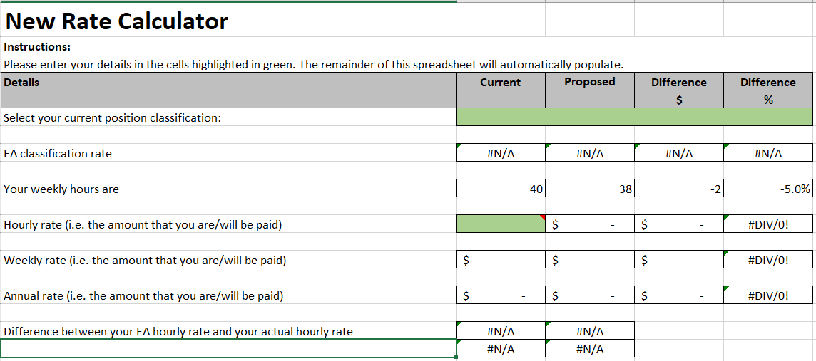
Step 2: Enter your current hourly rate into the second green box and press enter. The remaining fields will then automatically populate.

Frequently Asked Questions
If you’re not sure of what your classification is or what your current hourly rate is, please refer to your pay slip, check your profile in the HR Hive or contact HR.

This calculator has been designed to will help you understand what your new proposed hourly, weekly and annual rates will be and compares this with your current rates and also your EA classification. You will be able to see what the increase will be and how much higher than your existing rate and EA your wage is.
Q4. Why has it been proposed that employees who are paid above their EA classification rate are not automatically entitled to a CPI rate rise in 2022, 2023 and 2024?
- We have had a long history of paying our employees higher than their EA classification even though we haven’t been required to do so. We’ve done this because we’ve been able to afford it and because these individuals have deserved it. Our intention is to continue to pay our people above their respective EA classification if we can afford to do so and they have performed well.
Unfortunately, an employee performing well is not the only factor we must consider. If we cannot afford to provide an increase to an individual who is already paid higher than their EA classification rate and the Award, then we believe it is reasonable to reframe from doing so. The harsh reality is that we cannot give what we cannot afford.
Q5. Who should I contact if I have any questions?
- We will continue to provide updated information through employee briefings, Weekly HR Update emails and the document repository. In addition to this:
- You are welcome to submit questions at any time to hrmta@mirait.com.au
- You can also speak to George Buckley or Melissa Olsen
- Speak to your Employee Bargaining Representative
- Speak to your manager.

Frequently Asked Questions
Q6. What happens next?
- You will be asked to vote on the adoption of this proposed agreement on Tuesday 8 June 2021. Votes will be collected by the following people on this day:
- Glendenning: Rekha Pillai
- Lisarow: Mathew Shoesmith
The outcome of the vote will be communicated to all impacted employees on the 8th of June 2021 by George Buckley.
Q7. When will the proposed new terms take effect if the Agreement is approved?
If the majority of Employees support this proposal, the Agreement will be submitted to the Fair Work Commission for final approval. The new conditions will take effect 7 days after the Fair Work Commission formally approves the Agreement.
Q8. What will happen if the majority of Employees do not support the proposed Agreement?
If the majority of Employees do not support the Agreement, the current Agreement will remain in force and Bargaining representatives will re-commence the negotiation process. It is important to note, the current Agreement does not include a provision for a CPI wage increase to be applied in July 2021.
Useful links:
- The current 2016 MTA Enterprise Agreement
- The proposed 2021 MTA Enterprise Agreement
- New rate calculator
- EA Content and Award Comparison

